

System Requirement Document

Swift Connect System



February 2, 2024

A

Addis Ababa

Table of Contents

**1. Introduction** 1

**1.1 Purpose** 1

**1.2 Scope** 1

**2. User Profiles** 1

**3. Requirements Analysis** 1

**3.1 Functional Requirements** 1

**3.2 Non-Functional Requirements** 2

**3.2.1 Performance** 2

**3.2.2 Security** 2

**3.2.3 Usability** 2

**4. Wireframe/ user interface design** 2

**5. Conclusion** 4

# **1. Introduction**

## **1.1 Purpose**

The purpose of this document is to outline the requirements for the development of an automated SWIFT Connect service for Company A, allowing their business customers to seamlessly connect to the SWIFT network through a web interface and streamline request processing through the company’s CRM module.

## **1.2 Scope**

The SWIFT Connect Automation System will cover the entire process of onboarding business customers, from gathering requests on the web interface to processing them within the CRM module.

# **2. User Profiles**

Business Customers: Users initiating SWIFT Connect requests.

CRM Operators: Users responsible for processing and approving/rejecting SWIFT Connect requests.

# **3. Requirements Analysis**

## **3.1 Functional Requirements**

**User Registration:**

Business customers can register on the web interface.

**SWIFT Connect Request Form:**

Provide an intuitive form for users to input SWIFT Connect details.

Validate and ensure completeness of the information.

**Submission and Confirmation:**

Allow users to submit requests and provide confirmation messages.

**Request Queue:**

Display incoming SWIFT Connect requests.

**Request Processing:**

Enable CRM operators to review and process requests.

Options to approve, or reject additional information.

## **3.2 Non-Functional Requirements**

### **3.2.1 Performance**

**Response Time:**

Web interface response time should be faster.

### **3.2.2 Security**

**Data Encryption:**

Use encryption for sensitive information

Implement role-based access control in the CRM module.

### **3.2.3 Usability**

**Intuitive Design:**

Ensure a user-friendly design for both web and CRM interfaces.

# **4. Wireframe/ user interface design**

The following pictures shows the layout of the some module screens, including sections for incoming requests, request details.

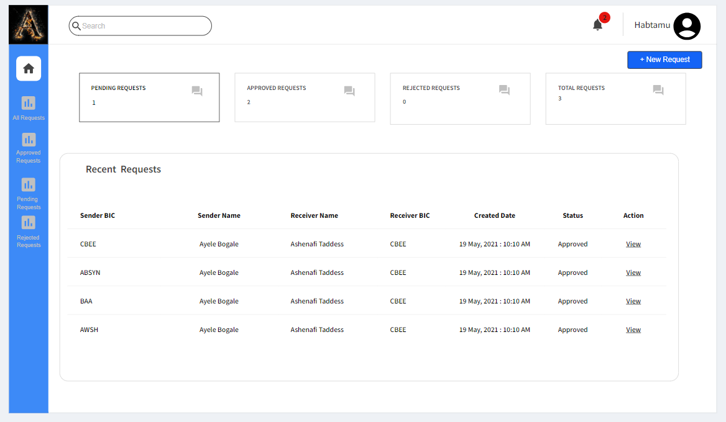

Figure 1 users dashboard page

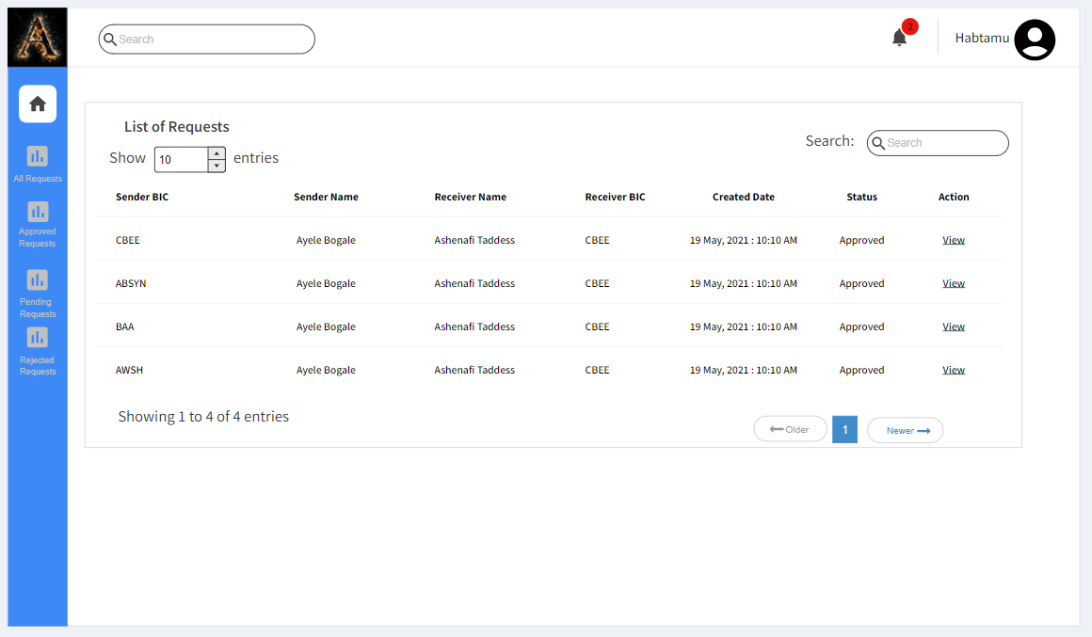

Figure 2 list of requests page

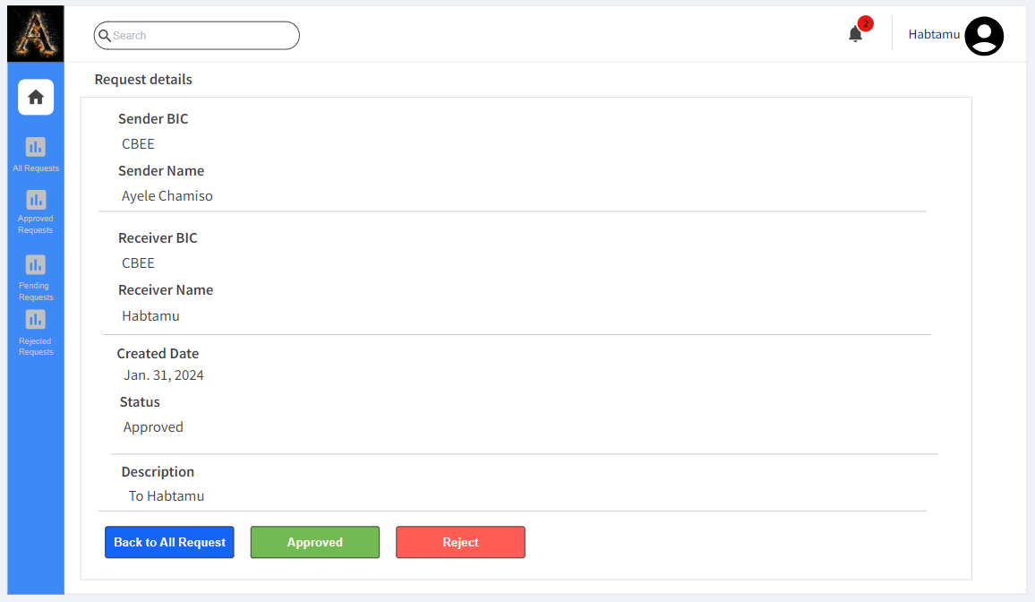

Figure 3 request details page

## **5. Conclusion**

This Software Requirement Document serves as a comprehensive guide for the development of the SWIFT Connect Automation System. It outlines the functionalities, user profiles, and design considerations for the system, ensuring a seamless and secure onboarding process for Company A's business customers.